Name: Solomzi Eugene Skolo
Module name: Web Development
Module code: WEDE5020

Student number: ST10543378

Contents
1. Organisation Overview 1
2.Website goals and objectives 2
3.Proposed Website features and functionality 2
4.Design and user Experience 3
5.Technical Requirements 5
6. Timeline and Milestones 5
7.Budget 5

1. Organisation Overview
Herbs Connect was founded in 2023 by a Pharmacist Dr Mthunzi Lenn who got the idea of mixing old fashioned healing and the knowledge equipped in medical school. However, this organization is dependent on researches.

- Vision statement
- Encourage the use of “Purely” natural resources or simply nature to improve human health to all.

- Mission Statement
- Provide a large quantity of herbal medicine across population to reduce the consumption of drug and syrup medicine

- Target audience
- Customers who are more than interested to keep themselves healthy and to those who value old healing /medicine such as herbs

2.Website goals and objectives
- Help this business build brand credibility due to the fact that customers become doubtful when serious things like medicine products are sold with no website to vouch for the products

- KPIs to measure website success
- Obtain 500+ visits on the website, thus increasing website traffic.
- Observing increased sales in the business

3.Proposed Website features and functionality

- Homepage
    - Show the herbal products
    - Easy page navigations

- About Us
- Show info about the business
- Business’s mission, vision and objectives
- Detail the products offered

- Product
- Show available herbal products
- Grant customers to search for products
- Display available products and order options

- Contact Us
- Include the business contact details, email address, physical address
- Display the business location

- Enquires
- Allow visitors/ customers to ask questions, ask or request information about the business

4.Design and user Experience

- Overall Design Aesthetic and Branding
- Nature design such as herbs and live that will reflect the company’s focus on herbal medicine
- Colour Scheme
- Dark green
- Light green
- White
- Brown

- Typography
- Headings in Large bold fonts, Subheadings in Medium font size, Body in Simple font to make content easy to read

- Layout and Design
- navigation menu
- Banner showing herbal medicine products
- About us sec
- Product sec
- Contact Info
- User Experience Consideration
- Easy navigation
- Clear layout
- Quick loading pages
- Legible Fonts

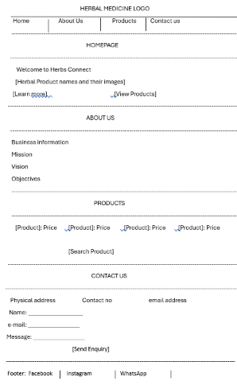

5.Technical Requirements
- Hosting Requirement
- Web hosting -file storage and make files available online
- Steady hosting with good security
- Domain Name
- www.herbsconnect.co.za

- Programming Languages and Frameworks
- HTML- make website structure
- CSS-Design colours, fonts and the layout
- JavaScript-engaging elements such as buttons, forms, menus

6. Timeline and Milestones
-The project will take 4 weeks
Week | Milestone
Week 1 | Planning the website
Week 2 | Designing website layouts, wireframes.
Week 3 | Develop Website using HTML, CSS, JavaScript
Week 4 | Test the website and deploying

7.Budget
-About R7000.00 will be needed to complete the project
- R4000.00 -Website development
- R250.00 for the domain name for a year
- R1200.00 for web hosting for a full year
- R1500.00 FOR Web maintenance
